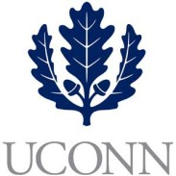**First Year Programs & Learning Community (FYP&LC)  
Faculty Courses and Curriculum Oversight Board**

**University of Connecticut   
January 2020**

**Digital Voting**

**Members:** Jaci VanHeest (Chair), Daniel Burkey, Terrence Cheng, James Chrobak, Tom Deans, Stephen Dyson, Mohammed Hussein, Alexia Smith, Friedemann Weidauer, Steven Zinn

**Ex Officio Members:** Maria Martinez, Kelly Bartlett, Melissa Foreman, Daniel Mercier, Dave Ouimette, Sarah Renn, Sarah Scheidel, Amanda Wilde, Paul Young

1. **New Instructors**
   1. Blesso (UNIV 1810 – Nutritional Sciences LC, Faculty)
   2. Sundara (UNIV 1800, Staff)
      1. As Sundara is in a graduate program, but doesn’t yet hold the degree, Sarah Scheidel would work with her one-on-one to provide additional assistance during the semester while instructing.