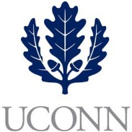**First Year Programs & Learning Community (FYP&LC)  
Faculty Courses and Curriculum Oversight Board**

**University of Connecticut   
December, 2019**

**Digital Voting**

**Present:** Daniel Burkey, Mohammed Hussein, Alexia Smith, Sarah Renn, Sarah Scheidel

**Absent:** Jaci VanHeest (Chair), Terrence Cheng, James Chrobak, Tom Deans, Stephen Dyson, Friedemann Weidauer, Steven Zinn, Maria Martinez, Kelly Bartlett, Melissa Foreman, Daniel Mercier, Dave Ouimette, Amanda Wilde, Paul Young

1. **New Instructors**
   1. Adams (UNIV 1810 – Pre-Pharmacy LC, Faculty) - *approved*
   2. Hayes (UNIV 1800, HESA Graduate Student) – *approved*
      1. Hayes will receive one-on-one coaching from Sarah Scheidel during the spring semester while teaching.