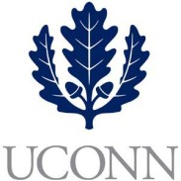**First Year Programs & Learning Community (FYP&LC)  
Faculty Courses and Curriculum Oversight Board**

**University of Connecticut   
October 12, 2017**

**9:00am-10:45am, Rowe 234**

**Members:** Jaci VanHeest (Chair), Daniel Burkey, James Chrobak, Tom Deans, Stephen Dyson, Robert McCarthy, Alexia Smith, Friedemann Weidauer, Steven Zinn

**Ex Officio Members:** Maria Martinez, Melissa Foreman, Dave Ouimette, Sarah Renn, Sarah Scheidel, Amanda Wilde

1. **October Minutes Approval**
2. **New Course Review**
   1. UNIV 1820 – Yalof – Politics
   2. UNIV 1820 – Cicocki - Mindset
3. **Instructor Review**
   1. Famularo (1810 – EcoHouse - HESA student)
   2. Yambor (1840 – Service Learning – Ed Psych student)
4. **Other Business**
   1. Review of UNIV 1800 International sample syllabus
   2. Faculty Oversight Board member terms
   3. Fall meeting schedule