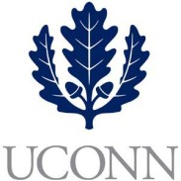**First Year Programs & Learning Community (FYP&LC)  
Faculty Courses and Curriculum Oversight Board**

**University of Connecticut   
October 18, 2018**

**9:00-10:00am, Rowe 234**

**Members:** Jaci VanHeest (Chair), Daniel Burkey, James Chrobak, Tom Deans, Stephen Dyson, Mohamed Hussein, Alexia Smith, Friedemann Weidauer, Steven Zinn

**Ex Officio Members:** Maria Martinez, Melissa Foreman, Dave Ouimette, Sarah Renn, Sarah Scheidel, Amanda Wilde

1. **Review of September 20, 2018 minutes**
2. **New Courses to Review**
   1. **Regional Campus Oversight**
      1. UNIV 1820 – Brown – Heartful Meditation: An Evolution of Consciousness
      2. UNIV 1820 – McGuire – Creative Arts and the Sea
3. **Other Topics**
   1. Syllabi Collection – Course Shell Oversight for UICC
   2. Committee on Civil Discourse and Dialoguing recommendations