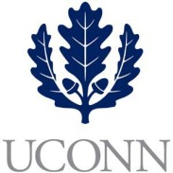**First Year Programs & Learning Community (FYP&LC)  
Faculty Courses and Curriculum Oversight Board**

**University of Connecticut   
December 13, 2018**

**3:00-4:00pm, Rowe 234**

**Members:** Jaci VanHeest (Chair), Daniel Burkey, James Chrobak, Tom Deans, Stephen Dyson, Mohamed Hussein, Alexia Smith, Friedemann Weidauer, Steven Zinn

**Ex Officio Members:** Maria Martinez, Melissa Foreman, Dave Ouimette, Sarah Renn, Sarah Scheidel, Amanda Wilde

1. **New Instructors**
   1. Kaeppel (UNIV 1800 – PhD Student)
2. **New Courses to Review**
   1. UNIV 1820 – Morenus – Connecting with METAS
   2. UNIV 1820 (Hartford) – Papacostas Ginalfi – Resilience through Mindfulness
3. **Other Topics**
   1. Developing a SOP for working with regional campuses
   2. Designating FCCOB members for winter session approvals